**Assisted Practice: 3.9 View snapshot**

This section will guide you to view a snapshot in your AWS account.

**Step 1:** To view snapshots, you need to navigate to the EC2 **dashboard** available on the panel on the left. Click on **snapshot** to view all available snapshots.

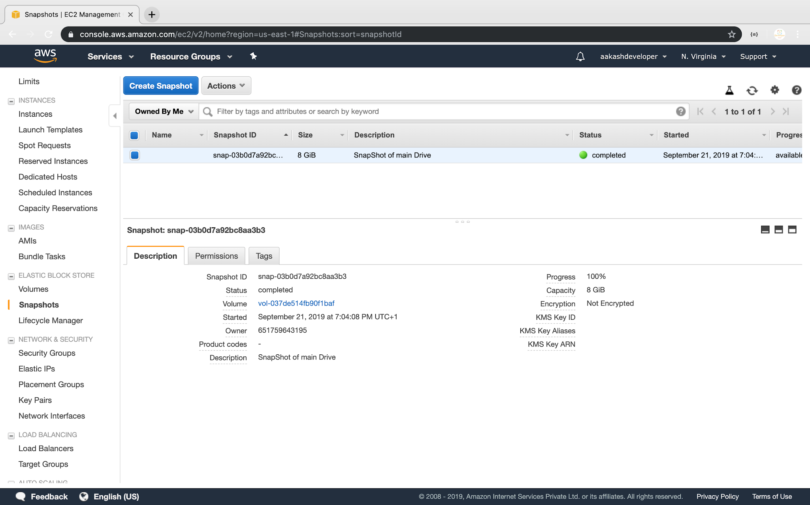

**Step 2:** Pushing the code to your GitHub repositories

* Open your command prompt and navigate to the folder where you have created your files.

**cd <folder path>**

* Initialize your repository using the following command:

**git init**

* Add all the files to your git repository using the following command:

**git add .**

* Commit the changes using the following command:

**git commit . -m “Changes have been committed.”**

* Push the files to the folder you initially created using the following command:

**git push -u origin master**